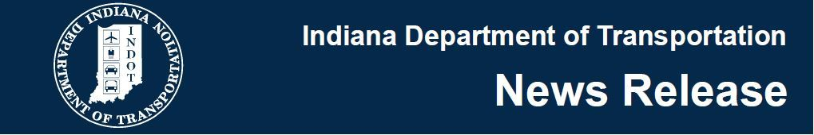
For Immediate Release
Tuesday, September 19, 2017
INDOT Begins Project Development to Reconstruct I-65/I-70 North Split in Indianapolis
INDIANAPOLIS – The Indiana Department of Transportation today announced that it is preparing to reconstruct the I-65/I-70 North Split interchange in downtown Indianapolis.
The North Split interchange was built 50 years ago and is nearing the end of its useful life. The interchange is one of the busiest in Indiana, accommodating approximately 170,000 vehicles per day. Reconstruction is needed to ensure public safety, decrease congestion and improve overall operations and efficiency for motorists.
The project will include:
- Reconstruction, rehabilitation or widening of 32 existing bridges and the addition of new bridges.
- Reconfiguring the I-65 entrance and exit ramps along 11th and 12th Streets to reduce congestion.
- Reconstructing the existing roadway to accommodate added through-lane capacity on I-65 and I-70 in the future.
INDOT’s project team recently began work on the Environmental Assessment, as required by the National Environmental Policy Act. INDOT is launching a comprehensive public outreach plan to educate the public on the project and to seek input. In the coming months, INDOT will work closely with City of Indianapolis officials, public safety agencies, downtown employers and nearby neighborhood groups to gain input on potential design and maintaining traffic flow and safety during construction.
Public meetings will be held begin in early 2018, with preliminary design to follow later in the year. INDOT will select a contractor team to design and build the project in 2019. Construction could begin as early as late 2019.

